Learning Outcomes
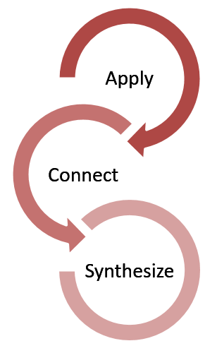
What will I learn?
An experiential learning (EL) activity allows you to:
Apply knowledge, skills and values from your course to a real-world experience (such as an internship, a case study, a capstone project, etc.)

Connect the experiences provided by the activity to your understanding of the course material. Describe the impact.

Synthesize and articulate how the experiences provided by the activity inform your personal, academic, and/or professional pursuits.
Learning outcomes describe the knowledge, skills and values you will acquire by the end of the EL activity. This will help you self-assess your progress and guide supervisors through their own assessment process. Learning goals can include:
- Core knowledge and skills: related directly to your field of study
- Transferable knowledge and skills: communication, self-awareness, social responsibility, etc.

Consider the following SMART questions when writing your goals:

Learning outcome example: By the end of my internship, I will be able to identify and describe the audience for the marketing plan I will develop.

Examples of action verbs
Analyze inspect test distinguish categorize critique differentiate catalogue diagnose appraise quantify calculate measure theorize experiment debate
______________________________________________________________________________________________
Apply sketch perform use solve respond practice construct role-play demonstrate conduct execute complete dramatize
______________________________________________________________________________________________
List record underline state define arrange name relate describe tell recall memorize repeat recognize label select reproduce
______________________________________________________________________________________________
Explain describe report translate express summarize identify classify discuss restate locate compare discuss review illustrate tell critique estimate reference
Use this template to help you define your learning outcomes and to plan how you will achieve them.
Learning Outcome  This is what I want to learn | Method  This is how I plan to learn it | Motivation  This is why I want to learn it | Reflection  This is how I show I’ve learned it
I will learn X. | I will learn X by doing Y. | I want to learn X so that I can do Z. | I know I have learned X because I can now do ABC.

