What is your topic or research question?

SEARCH STRATEGY
The key concept words in your research question become the foundation for your search strategy.
Write each key concept or idea in its own column. | ​​Enter key concept​ | ​​Enter key concept​ | ​​Enter key concept​ | ​​Enter key concept​
4. What synonyms or related terms to your key terms are there? | 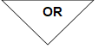  ​​Enter synonyms​ | ​​Enter synonyms​ | ​​Enter synonyms​ | ​​Enter synonyms​
Example: Indigenous AND (education OR pedagogy OR learning OR teaching) AND (“land based” OR “place based”) AND (university OR post secondary)
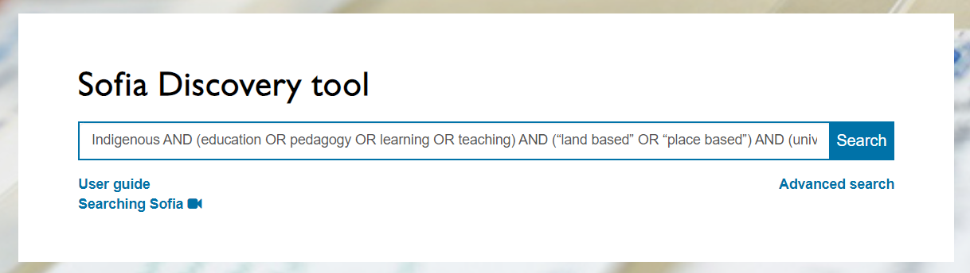
What will your search strategy look like in the Sofia Discovery Tool:

Write down any useful subject headings you find for your topic:
Example: Indigenous peoples – Education

Did you find any useful books or journal articles? Send them to yourself using the Share button!
